A Trip To The Zoo
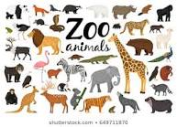
Touch an animal that is tall.
Touch an animal that can hop.
Touch an animal that rrrrrroars!
Did you know an elephant is the only animal that cannot jump!
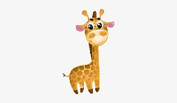
Giraffes are very quiet animals! They sometimes whistle to call their babies. Giraffes also use their eyes to communicate. Check it out! Click the giraffe!

Draw your favorite zoo animal.
Send me your picture!
mkeating@houstonisd.org Science 102 A

